Advisory Scientific Committee
Diana AMANTEA (CS)
Sebastiano ANDO’ (CS)
Stefano AQUARO (CS)
Maria Tiziana CORASANITI (CZ)
Francesca FALLARINO (PG)
Cristina GIRALDI (CS)
Luigi A MORRONE (CS)
Carmelo NOBILE (CS)
Maria Luisa PANNO (CS)
Rossella RUSSO (CS)
Carlo TORTI (CZ)
Mario VELTRI (CS)
Marilù VULNERA (CS)

One Health Approach to
Fight Antimicrobial Resistance

Members of the Consulting Committee for Veterinary Drug (Ministry of Health, Rome)
Silvio BORRELLO (President)
Carlo GIRARDI (Vice President)
Vincenzo APPICCIUTOLI
Giacinto BAGETTA
Monica BARTOLOMEI
Aldo BENEVELLI
Paola BERTOCCHI
Luigi BONIZZI
Domenico BRITTI
Carla Marcella CARAMELLA
Marta DAL CIN
Luigi GAIDELLA
Stefano GATTO
Giuseppe IOVANE
Luigi INTORRE
Livia MANNA
Fulvio MARSILIO
Paolo PASQUALI
Alberto VERGARA

Local Organizing Committee
Annagrazia ADORNETTO (CS)
Rosalinda BRUNO (CS)
Loredana MAURO (CS)
Domenico MONTELEONE (RM)
Laura ROMBOLA’ (CS)

Scientific Secretariat
Damiana SCUTERI (CS)
damianascuteri@gmail.com

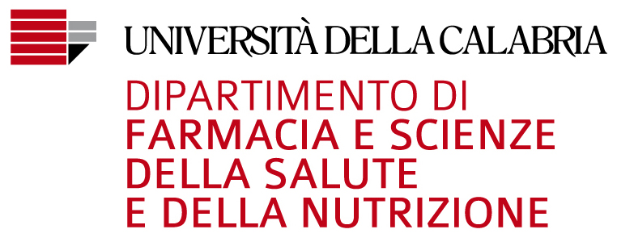
Scuola di Specializzazione in Patologia Clinica e Biochimica Clinica
Dipartimento di Eccellenza finanziato
ai sensi della Legge 232/2016

April 11th-12th, 2019

University of Calabria,
Aula MagnaComplex,
Rende (Cosenza) Italy

Scientific Programme

Thursday April 11th

17.30 Introduction and Rational
Giacinto Bagetta, Department of Health Science and Nutrition, University of Calabria, Rende (CS)

Wellcome Address

Gino Mirocle Crisci, Rector, University of Calabria, Rende (CS)

Maria Luisa Panno, Head of Department of Pharmacy, Health Science and Nutrition, University of Calabria, Rende (CS)

Marcello Manna, Major of Rende (CS)

Silvio Borrello, Head of DG for Animal Health and Veterinary Drugs, Ministry of Health, (Rome)

Antonio Limone, Head of Istituto Zooprofilattico Sperimentale del Mezzogiorno, Portici (NA)

Commemoration Cerimony

Chairpersons: Domenico Britti, University Magna Graecia, Catanzaro & Antonio Pugliese, University of Messina

“In Memory of Prof. Orazio Catarsini”

18.30 Opening Lecture

Chairperson: Diana Amantea, University of Calabria, Rende (CS)

Speaker: Francesca Fallarino, Department of Experimental Medicine, University of Perugia
Biotech Research Innovation and potential impact in Antibiotic Resistance

19.15 Welcome cocktail

Friday April 12th

Chairpersons: Giuseppe Iovane, University of Naples and Carmelo Nobile, University of Calabria, Rende (CS)

9.00 Silvio Borrello, Head of DG for Animal Health and Veterinary Drugs, Ministry of Health, Rome
Implementation of Electronic Prescription in Veterinary Medicine

9.30 Paolo Pasquali, National Institute of Health, Rome
Use of Vaccines for Spread of Infection and Antimicrobial Use Control in Veterinary Medicine

10.00 Paola Roncada, University Magna Grecia, Catanzaro
Omics Sciences to assess food safety and quality

10.30 Coffee Break

Chairpersons: Maria Pavia, University Magna Graecia, Catanzaro and Mario Veltri, Annunziata Hospital, Cosenza

11.00 Luigi Bonizzi, Department of Veterinary Medicine, University of Milan
Proposal for Novel Approaches to Infection Disease Prevention in Livestock Facilities

11.30 Cristina Giraldi, Microbiology and Virology Unit, Annunziata Hospital, Cosenza
Bacterial Multiresistance: European, National and Local Epidemiology

12.00 Carlo Torti, Department of Medical and Surgery Sciences, University Magna Graecia, Catanzaro
Infection Control and Prevention and Antibiotic Stewardship to Protect Patients

12.30 Concluding Remarks
Prof. Stefano Aquaro, University of Calabria, Rende (CS)

13.00 Light Lunch

