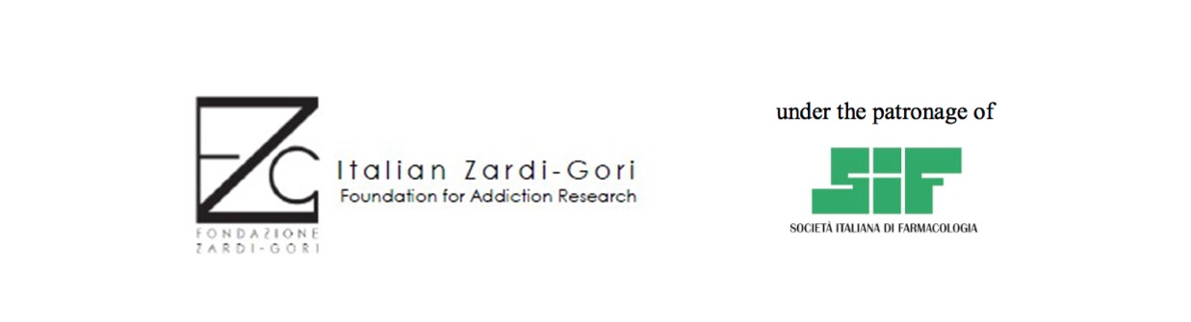

N° 5 12-month-long research grants, for a total amount of 135000 Euro (before tax), aimed at promoting basic and translational research in excellent Italian institutions.

RESEARCH AREAS

The research grants of Fondazione Zardi Gori are aimed at supporting top profile projects characterized by a high level of innovation in the field of drug addiction and comorbid diseases.

ELIGIBILITY CRITERIA

The research grants offered by the Fondazione Zardi Gori are addressed to:

12-month fellowship

Experimental and Translational research Italian and international researchers holding a scientific degree preferably in Medicine, Biological and Pharmaceutical Sciences, or Biotechnologies. In addition, a clinical and/or post-degree research experience (specialization or PhD) in health-related fields is required. Selected candidates must carry out their research work in excellent institutions in Italy.

The 12-month fellowships will only be awarded to researchers (Italian and/or international) for research work in Italian institutions. There are no fellowships available for researchers that will develop their research project outside of Italy.
For ALL the fellowships:

All candidates must have officially obtained the PhD or specialization title within 6 years from the present call.

Candidates who have been absent from work for maternity/paternity leave or serious illness in the two years preceding the submission date, should state this in the CV, indicating also the period of absence. The scientific Committee will take this issue into account during the evaluation procedure.

Candidates must have at least two original papers (or one original paper and one review) in peer-reviewed international journals of which at least one original paper is as first, second/last/corresponding author. Posters/abstracts at conferences, meeting proceedings or book chapters should not be included in the list of publications.

Candidates who have previously been granted Zardi-Gori fellowships can apply for a second year to continue their project. In this case a short description , indicating key findings and results of the project must be provided.

All the materials required must be written in English.

EVALUATION PROCEDURES

All applications sent by the deadline and meeting the eligibility criteria will be evaluated by a Scientific Committee.

Candidates will be awarded funding based on the following meritocratic criteria:

Quality of the scientific curriculum vitae.

In particular, the quality of publications will be included in the election criteria. Only original papers and reviews will be evaluated for the publication record. Posters/abstracts at conferences, meeting proceedings, and book chapters will not be considered for the evaluation of publications but can be included, separately, in the CV.

Quality of the proposed research project.

Projects should be of the highest originality and scientific and/or translational impact. The potential of the project to generate substantial contributions to the field, will be carefully evaluated.

Quality of the Hosting laboratory or Institution.

Quality of the Host Institution (in terms of laboratories, facilities, etc.) as well as the competence of the Head of the hosting laboratory (expertise in the field of the project, mentoring, international standing, etc.) will be evaluated.

ENROLMENT PROCEDURE

To start submission of the application, go to the web site: www.fondazionezardigori.com please enter “Ricerca“ , “Bandi “and then you will be directed to the correct application form.

You will be asked to fill in the form with a description of your CV (max 4000 characters including spaces), a list of your scientific peer-reviewed publications a short abstract of the proposed project (max 2000 characters including spaces) and the description of the proposed research project (background, experimental plan, and description of expected results and future applications, max 9000 characters including spaces).

Then prepare the following documents.:

- Two letters of recommendation (mandatory).

- A letter of acceptance by the host Institute, signed by the legal representative of the Institute (mandatory). This letter should clearly report the declaration that, in case the candidate will be awarded a Fondazione Zardi Gori fellowship, he/she will be able to develop his/her project in the indicated Institution. Please report on the acceptance letter the name of the laboratory, the name of the PI/Professor/Group leader who will supervise the candidate, the Department and the Institution where the research will be developed.

- Preliminary results of the project (if available) with a maximum of two A4 pages.
All files must be in PDF format.

Submit your application (the form and the other files) to the following e-mail:

segreteria@fondazionezardigori.com.

FUNDING REGULATIONS

The total amount of the fellowship is 27000 Euro for each grant (before tax) for 12 months. The fellowship is intended only to pay the researcher’s salary and cannot be used in other ways (lab reagents and supplies, etc.).

The fellowship can be interrupted at any moment; it is sufficient to give timely communication to Fondazione Zardi Gori by e-mail at : segreteria@fondazionezardigori.it.

The fellowship can NOT be combined with any other form of bursary; similarly, the fellowship is not compatible with subordinate working contracts, either temporary or permanent; the fellowship is compatible with funding of a different nature from the above described, provided that it does not exceed a total of Euro 10000 (before tax).

Please note that all expenses contemplated in the DGL 81/2008 are defrayable of the hosting Institute. Please state clearly in the acceptance letter that the hosting Institute agrees to this clause.

REPORTS OF THE SCIENTIFIC ACTIVITY

Successful candidates will be required to produce short reports on their research activity, describing their progress and results obtained.

One mid-term report after 6 months and one final report at the end of the 12 months are required for both experimental and clinical fellowships.

The mid-term report is mandatory between the end of the sixth and the first two weeks of the seventh month of the fellowship. Please note that if Fondazione Zardi Gori does not receive the mid-term report by this deadline, payment will be suspended until the report is submitted. The final report must be submitted at least two weeks before the end of the 12th month. The last payment will not be paid until Fondazione Zardi Gori has received the final report.
All reports must be sent to the address: segretria@fondazionezardigori.com
DURATION

Grants awarded by Fondazione Zardi Gori will have a duration of 12 months and will start on the January 1st 2020 The starting date can be postponed no later than April 1st 2020 It will not be possible, under any circumstances, to further postpone the starting date.

OBLIGATIONS FOR RECIPIENT FELLOWS

It is mandatory for all Fellows to acknowledge Fondazione Zardi Gori in any publications, generated from work conducted by the fellow during the period he/she was benefiting of Fondazione Zardi Gori fellowship.

Once a candidate has been granted the fellowship, by accepting it, he/she will take the responsibility to cooperate with Fondazione Zardi Gori in its activities of dissemination and to promotion of its scientific research, whenever required. The candidate must therefore be available to be interviewed for printed and online publication and participate in promotional events (such as a press conference, meetings in schools, and one or two events with the general public) or other scientific dissemination activities organized by Fondazione Zardi Gori.

Italian researchers working in Italy will be asked to organize at least one meeting in one school in their city/region during the year of the fellowship, with the goal of promoting the scientific knowledge of the neurobiology of addiction. More information will follow to the awarded candidates.

DEADLINE

All material must be sent no later than 12th September 2019, 23.59 (Central European Time, CET).

After receiving the application a confirmation email at the email address supplied will be sent. For any further explanation, feel free to contact Fondazione Zardi Gori at the following e-mail address:
segreteria@fondazionezardigori.com or dparolaro@fondazionezardigori.com.

